Hurley Reformed Church
Blue Christmas Service
December 16, 2021; 6:30 pm

Rev. William Appleyard-Pekich, Pastor
Jane Barsumian, Organist and Choir Director

CALL TO WORSHIP
Leader: Jesus said, “Come unto me all you who labor and are heavy
laden and I will give you rest.” And so we invite each other to this time of worship.
All: Quiet yourself in this busy holiday season, find space for yourself.
Leader: Come, cast aside your burdensome cares and put aside your laborious pursuits.
All: Give your time to God, and rest in God for a little while!

HYMN #157, “Come, Thou Long-Expected Jesus”

READING “First Coming” by Madeleine L'Engle

HYMN #163, “O Come, O Come, Emmanuel”

SCRIPTURE: Psalm 13

CANDLE LIGHTING LITANY
Reader: God of Light and Life, we light this candle for all those who are
struggling with issues involving physical or mental health. May its light remind us all of the healing available to us in Christ Jesus. Hear our prayers.

Silence
Reader: We light this candle for all those who are struggling with financial
concerns, job loss, or debt. May its light remind us all that you are the Great Provider, you will give us our daily bread. Hear our prayers.

Silence

Reader: We light this candle for all those who grieve. May its light remind us that we are not orphaned, we are not alone. Hear our prayers.
Silence
Reader: We light this candle for all those who are victims of violence in any of its forms. May its light lead us to peace, safety, and truth. Hear our prayers.
Silence
Reader: We light this candle for all those who are experiencing the pain of broken relationships with family, children, spouses, and friends. May its light remind us of the pure communion you desire for all your creation. Hear our prayers.
Silence
Reader: We light this candle for all those who are estranged from you, who are besieged with doubts, who are overwhelmed by the world and do not claim your presence in their lives Lord, may the light of your love lead us all home to you. Hear our Prayers.

Silence

You may come forward to light a candle and offer a prayer, remembering that Christ is the light who comes into our darkness, whatever and wherever we experience it.

SCRIPTURE: Luke 2:1-20

CLOSING PRAYER

HYMN #171, “Silent Night! Holy Night!”

BENEDICTION

#157 Come Thou Long-expected Jesus

Come, Thou long expected Jesus
Born to set Thy people free;
From our fears and sins release us,
Let us find our rest in Thee.
Israel's strength and consolation,
Hope of all the earth Thou art;
Dear desire of every nation,
Joy of every longing heart.

Born Thy people to deliver,
Born a child and yet a King,
Born to reign in us forever,
Now Thy gracious kingdom bring.
By Thine own eternal Spirit
Rule in all our hearts alone;
By Thine all sufficient merit,
Raise us to Thy glorious throne.

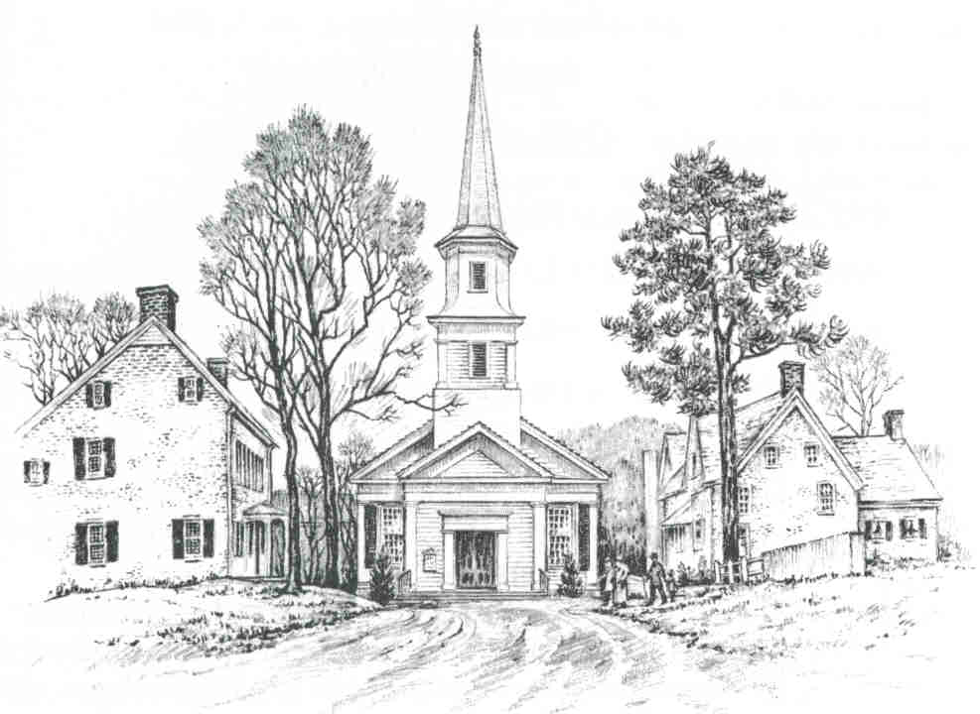

Hurley Reformed Church
Hurley, New York

The Rev. William Appleyard-Pekich
Minister of Word and Sacrament

Welcome
May the doors of this church be wide enough
to receive all who need human love and fellowship, and a Father’s care;
and narrow enough to shut out all envy and hate.

Enter to Worship Depart to Serve

#163 O Come O Come

O Come, O come, Emmanuel, And ransom captive
Israel, That mourns in lowly exile here until
the Son of God apprear.

Rejoice! Rejoice! Emmanuel Shall come to
Thee, O Israel!

O Come, Thou Day-spring, come and cheer
our spirits by Thine advent here. Disperse the
gloomy clouds of night, and death’s dark shadows
put to flight.

Rejoice! Rejoice! Emmanuel Shall come to
Thee, O Israel!

O come, Thou Wisdom from on high, and order all
things far and night. To us the path of knowledge
show, and cause us in her ways to go.

Rejoice! Rejoice! Emmanuel Shall come to
Thee, O Israel!

O come, Desire of nations; bind All peoples in
one heart and mind. Bid envy, strife, and quarrels
cease; Fill the whole world with heaven’s peace.

Rejoice! Rejoice! Emmanuel Shall come to
Thee, O Israel!

#171 Silent Night! Holy Night!

Silent night, holy night
All is calm, all is bright
'Round yon virgin Mother and Child
Holy infant so tender and mild
Sleep in heavenly peace
Sleep in heavenly peace

Silent night, holy night!
Shepherds quake at the sight!
Glories stream from heaven afar;
Heavenly hosts sing Al-le-lu-ia!
Christ the Savior is born!
Christ the Savior is born!

Silent night, holy night!
Wondrous star, lend thy light.
With the angels let us sing
Al-le-lu-ia to our King.
Christ the Savior is born:
Christ the Savior is born.

Silent night, holy night
Son of God, oh, love's pure light
Radiant beams from Thy holy face
With the dawn of redeeming grace
Jesus, Lord at Thy birth
Jesus, Lord at Thy birth

